|  |
| --- |
| University of Suffolk |
| Game Design Document |
| Group 6 |

|  |
| --- |
| By Jack E. Massey S189328 |

Narrative: -

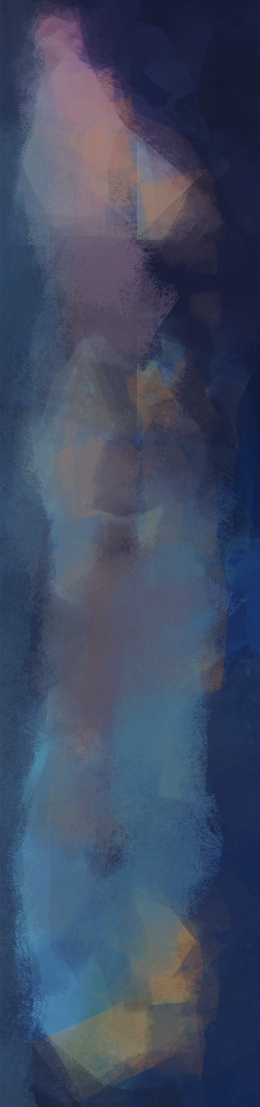

# Synopsis:

In a mysterious land, a small creature called Ciwtylluan has fallen out of his nest causing him  
to fall into a cave hidden deep below the Jungle where he lives. Seeing his situation, a God of  
Nature comes to help him return to his nest. But they have a long journey, through the dark  
depths of the Cave, the fiery inferno of the Dead place, and the savagery of the Jungle.

# Full story:

In a jungle, a young creature called Ciwtylluan, rests in his nest. Suddenly, a tremor causes Ciwtylluan to fall from his nest into a cavern far below. A god of nature seeing the creature’s predicament, decides to help him return to his nest.

Ciwtylluan seeing there is no way to return home from the way came follows a breeze that   
indicates that there may be another way out.  
The God of Nature begins to guide Ciwtylluan creature through the cave, helping him to   
avoid perilous falls and some dangerous creatures lurking in the shadows.  
Eventually Ciwtylluan finds the exit to the cave and goes through it. On the other side reveals   
the dead place. A hell pit full of fire and significantly more deadly dangers than there were experienced in the previous area.

The god of nature seeing that this isn’t any better than the place before and decides to   
continue to help Ciwtylluan traverses through the dead place. After getting through the   
harsh dangers of the dead lands, Ciwtylluan reaches the edge of the jungle where he lives.

But the god of nature knows the dangers of the Jungle and so continues to help Ciwtylluan   
traverse the jungle to reach his nest.  
It turns out that jungle has far more numerous and dangers than there were in both the Cave  
 and the dead lands combined.  
Eventually passing through the many challenges that awaited ahead of Ciwtylluan.   
He eventually reaches his home and enters his nest where his mum is looking for him in   
distress. Seeing he has returned help him into the nest. The game ends with camera panning   
out. But as the screen fades to black, a sound of distress can be heard.

-This is From the Narrative Design File.

Characters: -



# The Main Character:

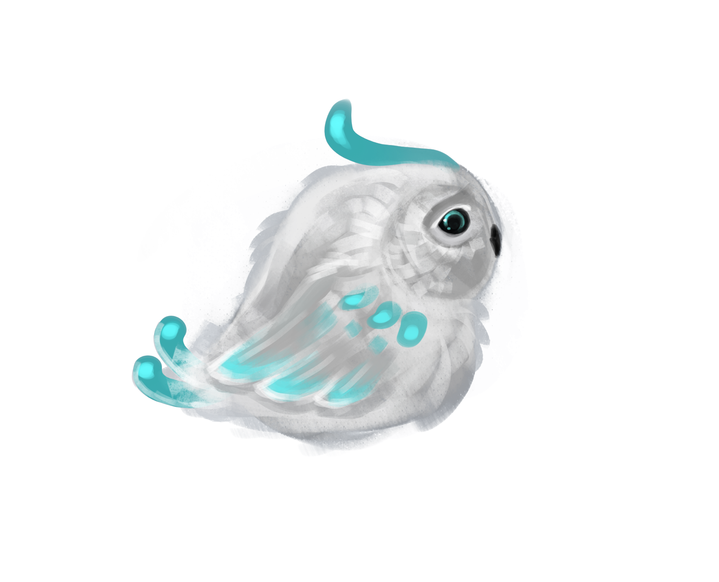

The main character, is called Ciwtylluan and is designed to look like a Juvenile owl.  
With his cute design players will definitely feel more empathy for as he looks innocent.  
With his design he will also stand out of all the backgrounds as because of his white and turquoise colouring.

The Main Character’s design by Marta

He may also have a growth which would indicate that he is dying, because he was infected by   
some mysterious and deadly fungus/disease.

The name Ciwtylluan is welsh and come from the words Ciwt and Tylluan, meaning Cute Owl.

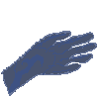

# God of Nature:

This is the character that the player takes control of. It’ll be represented in the game by the mouse cursor when playing.

The character will be very empathetic and will want to help the Ciwtylluan return to his mother. Overall this character is a blank   
  
slate, so really the god of nature is the player.

The current God’s Hand asset by Eva

# The Mum (Mother):

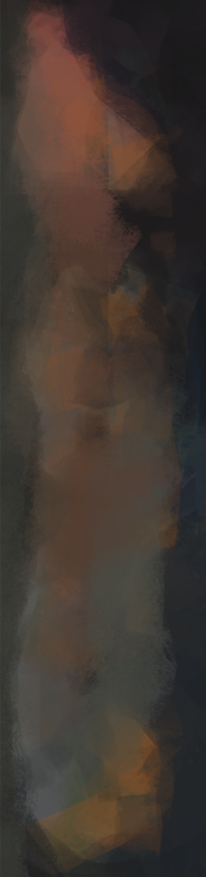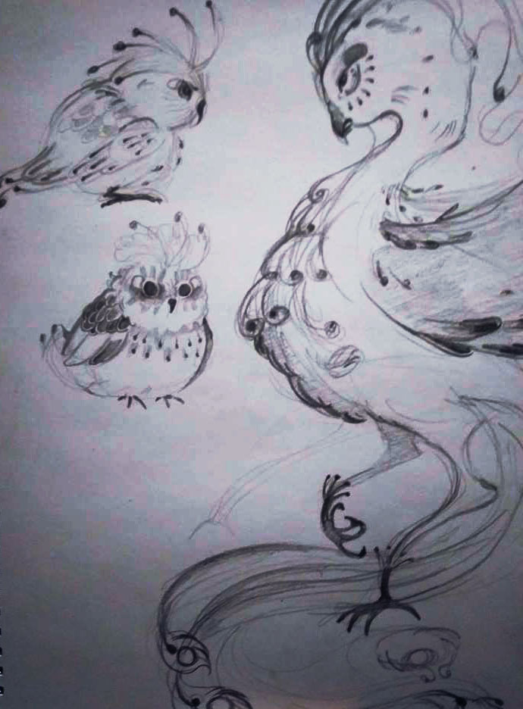

The mother won’t get enough screen time to be fully developed, and really doesn’t need too much at all.  
Obviously she cares for Ciwtylluan and wants him back to their nest.

She’ll be designed as a more elegant and magnificent creature, but should show concern and worry about his whereabouts.

Concept art of the Main Character and his mum By Marta

Assets: -

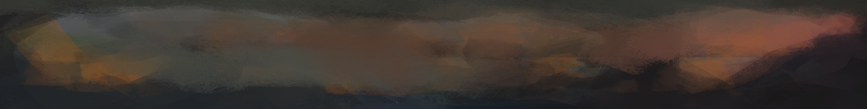

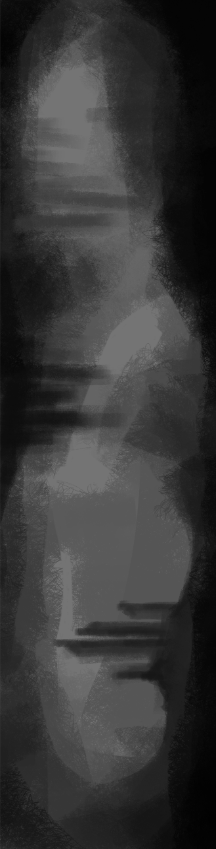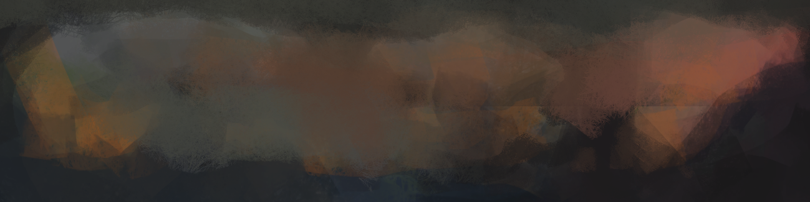Level Design:

Programming: -

